Advantages of 1DCNv3 (Deformable Convolutional Networks v3)
DCNv3 is an extension of traditional convolutional neural networks, aiming to enhance the flexibility and accuracy of feature extraction. By introducing deformable convolution, it enables the convolutional kernel to adapt to different shapes and scales, thereby better capturing non-rigid objects and complex structures in images. DCNv3 enhances the adaptability of the convolutional kernel by learning adaptive sampling positions in each convolutional layer, thereby improving the robustness to object deformations and the expressive power of the network. This approach performs excellently in image detection and segmentation tasks.
- Integrate DCNv3 into YOLOv8
  - Step 1
Locate the following directory: ultralytics/nn/modules, then create a DCNv3.py file in this directory. The file name can be set according to your own preference. Finally, copy the core code of DCNv3 into it

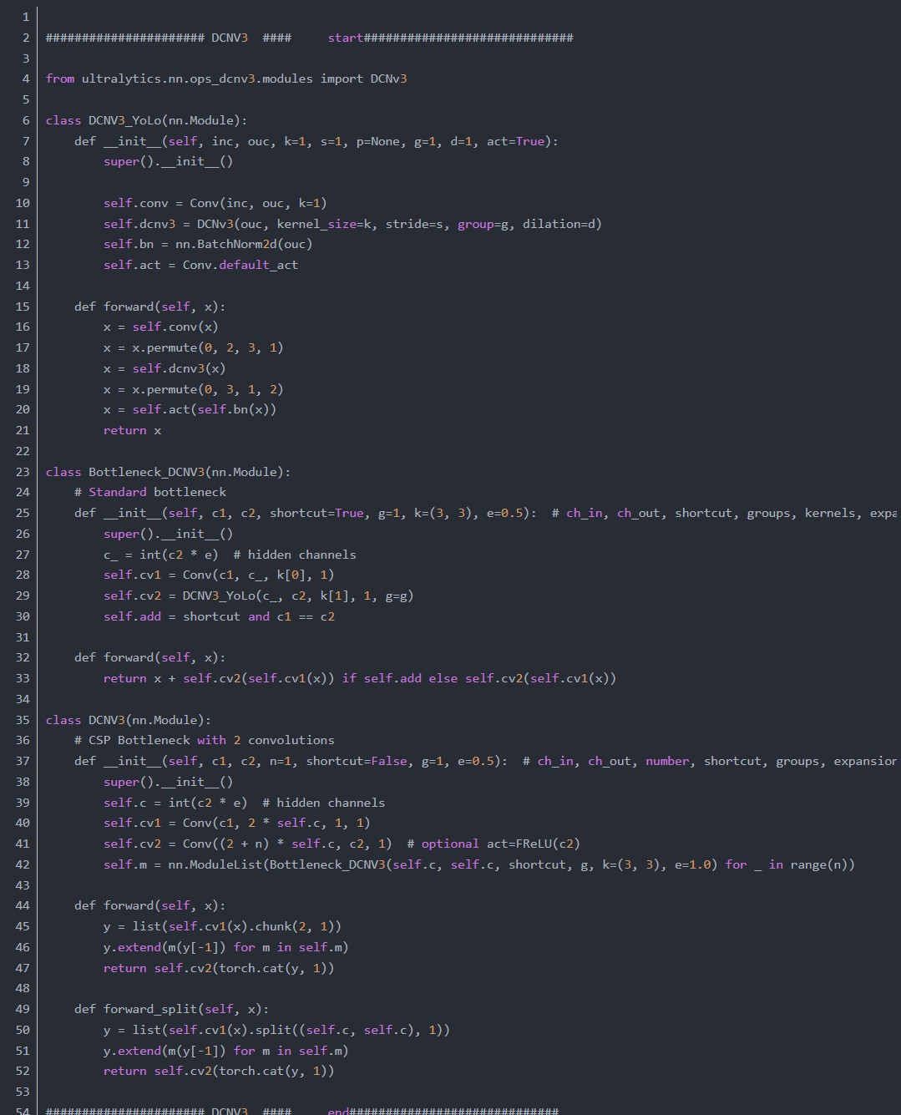
2.2 Step 2
Import our module in task.py

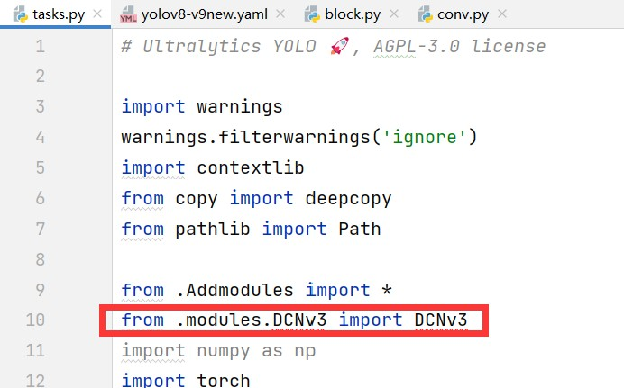



2.3 Step Three














Register our module in the parse_model method of task.py Note that additions are required in two locations
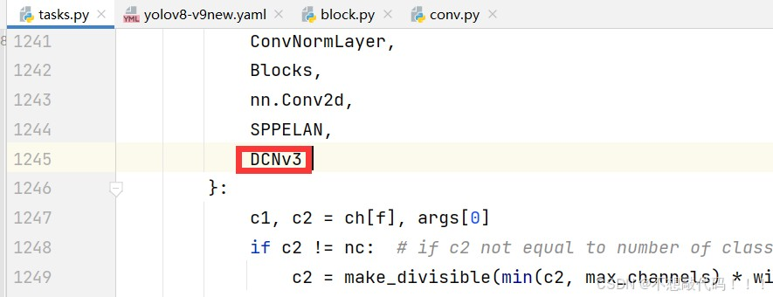
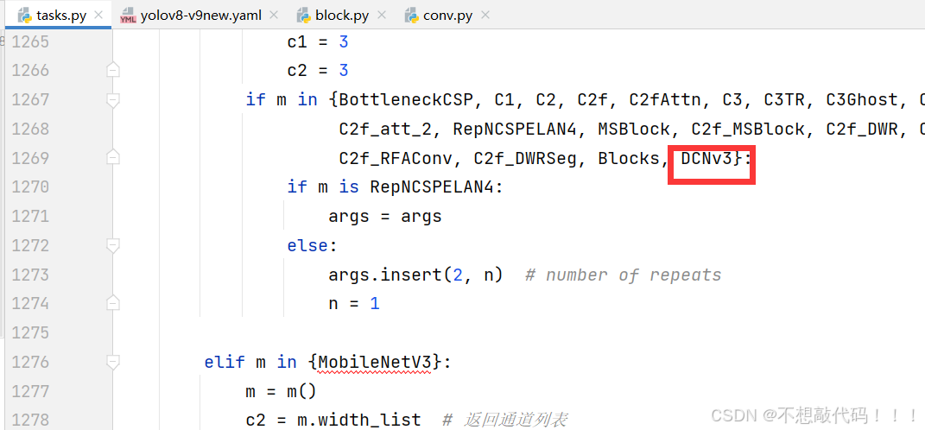

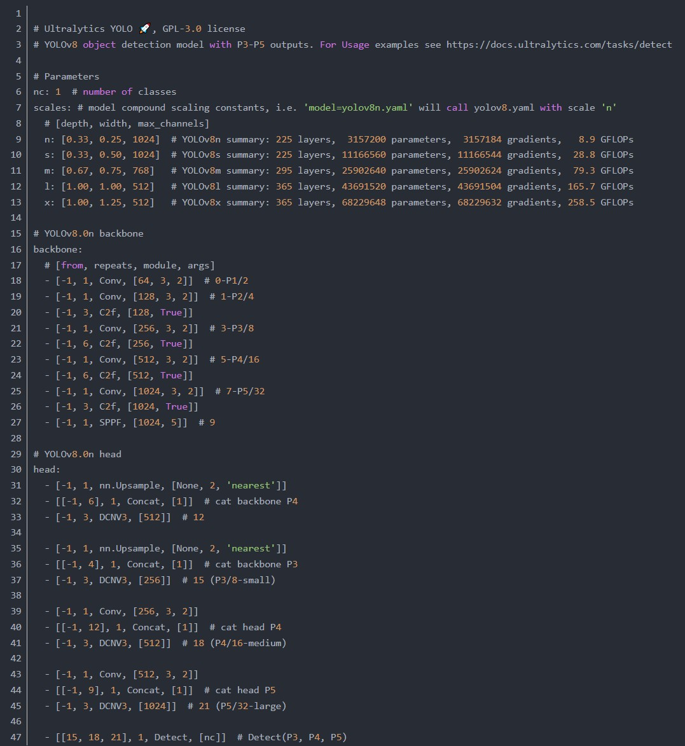
"Registration is successful. Copy the following YAML file and run it directly." yaml file

